SOFS Request System Details
This manual will provide directions on how to use the SOFs Request System. The SOFS Request System can be used to reimburse a member, pay a vendor, or transfer money to a department or another SOFS group. This new online system replaces the paper version of the Payment Request Voucher, but all deposits for your RSO must still be done in person at the SOFS Office. The SOFS Request System can also be used to review past requests processed through the Payment Request System.
Before any RSO funds are used, please follow the protocols that your RSO has created related to the handling of RSO funds, but in general, before any transactions take place, please obtain the appropriate approvals from your RSO leadership to ensure that funds can be used for appropriate purposes and are reimbursable.

Using SOFS Request System

Step 1. (Visit SOFs Request Website & Login)
Visit the SOFS request system website on UNL.edu and log-in using your credentials.
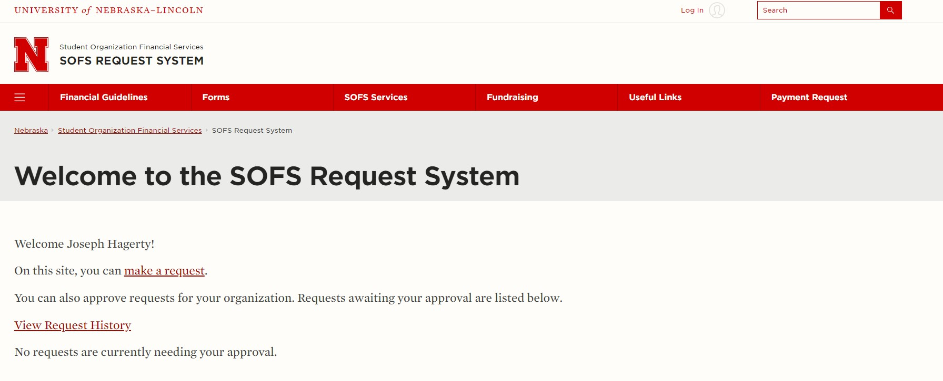

Step 2. (Bookmark & Start SOFS Submission Request)
- Bookmark the SOFS Request System webpage so you can access it for future requests.
- After you have logged in, your name should appear after the welcome message. To begin your SOFS request, click the “Make a Request Hyperlink”



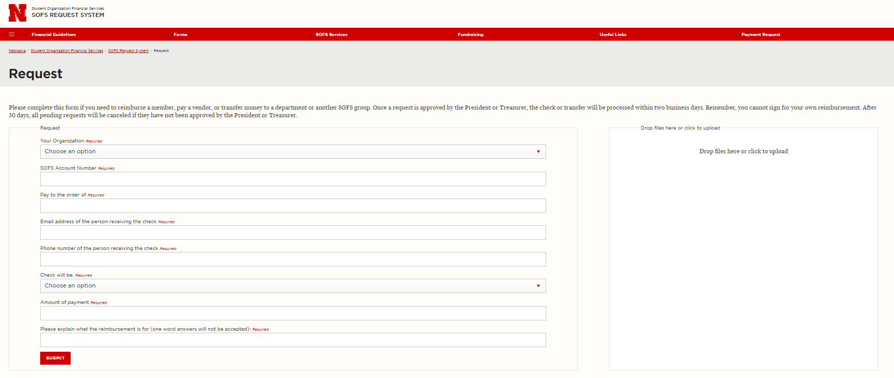
Step 3. (Select RSO & Start SOFS Submission Request)
- Select the organization that you are submitting your request on behalf of by choosing the organization from the
“Your Organization” drop down menu Ex.) ITS-Alpha Dogs
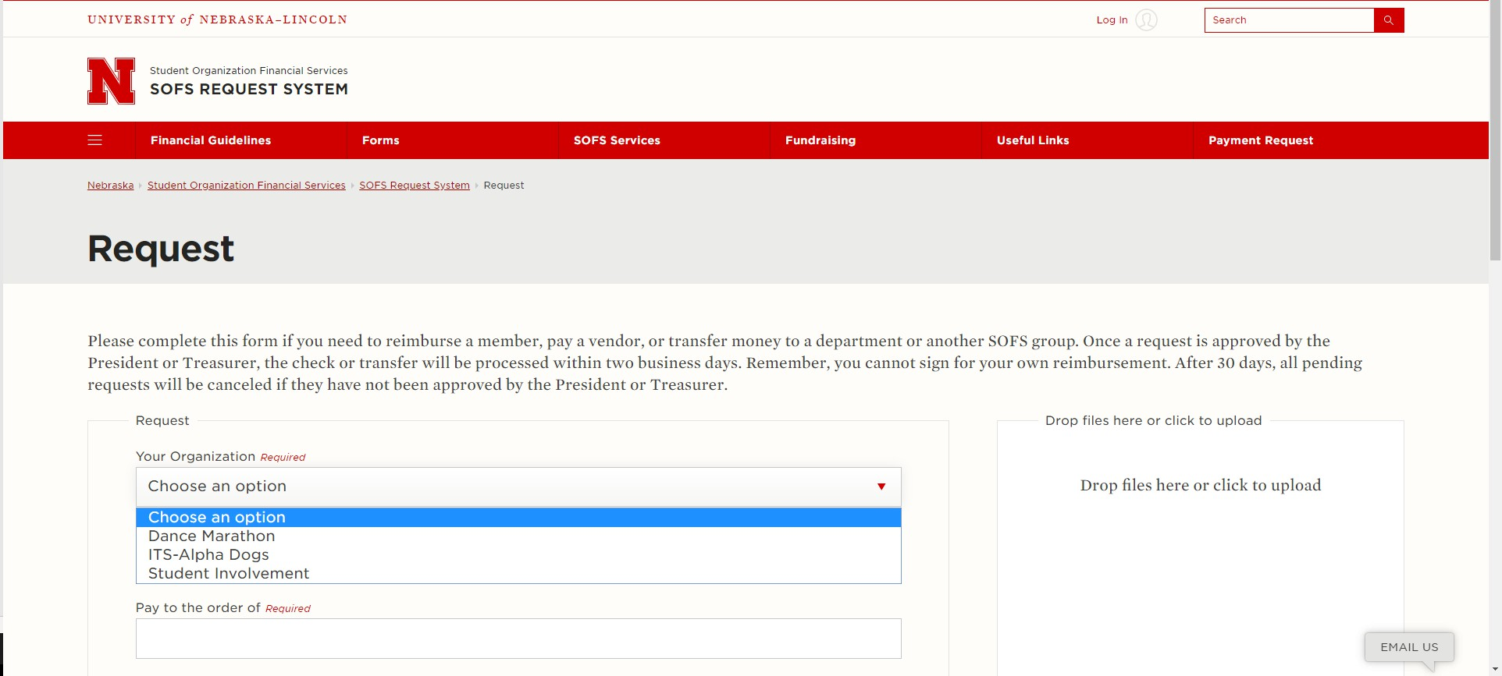
NOTE: If you have not been added to your RSO’s roster, you will be unable to submit a request using the SOFS Request System. To be added to your organization’s roster, reach out to one of the officers of your RSO and have them add you, or request to join the RSO on your RSO’s Homepage on NvolveU.

Step 4. (Fill Out Remaining Fields, Upload Documentation & Submit Request)
- Fill out the remaining fields on the request form and submit a receipt or proper documentation by dropping files in the “Drop files here or click to upload” box on the far left side of the screen.
  - NOTE: You will need to submit an itemized receipt that lists the individual items that have been purchased in order to get a request using the SOFS Request System.
- Submit request using the red “Submit” button on the bottom of the page.

Step 5. (Approvals)
Advisors do not use the system
- Your President and Treasurer will receive an email requesting their approval of your reimbursement request and once they approve, an email will be sent to your advisor requesting their approval
  - NOTE: Emails will be sent to student’s Huskers.unl.edu email accounts
- Once the advisor approves the request the request is sent to the SOFS staff to be processed.
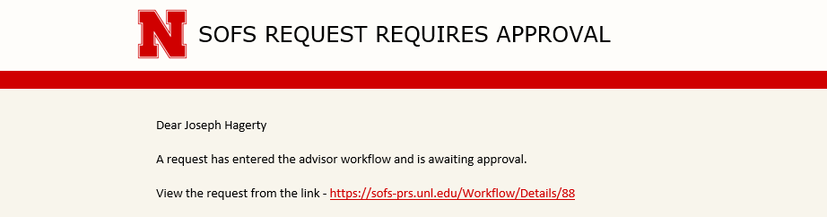

Viewing History & Status of SOFS Requests

Viewing Requests
- To view any request that you have inputted into the system or that you have approved, click the “View Request History” hyperlink on the homepage of the SOFs Request System Website.
  - NOTE: Any requests that you did not personally input into the system or approve will not show up on
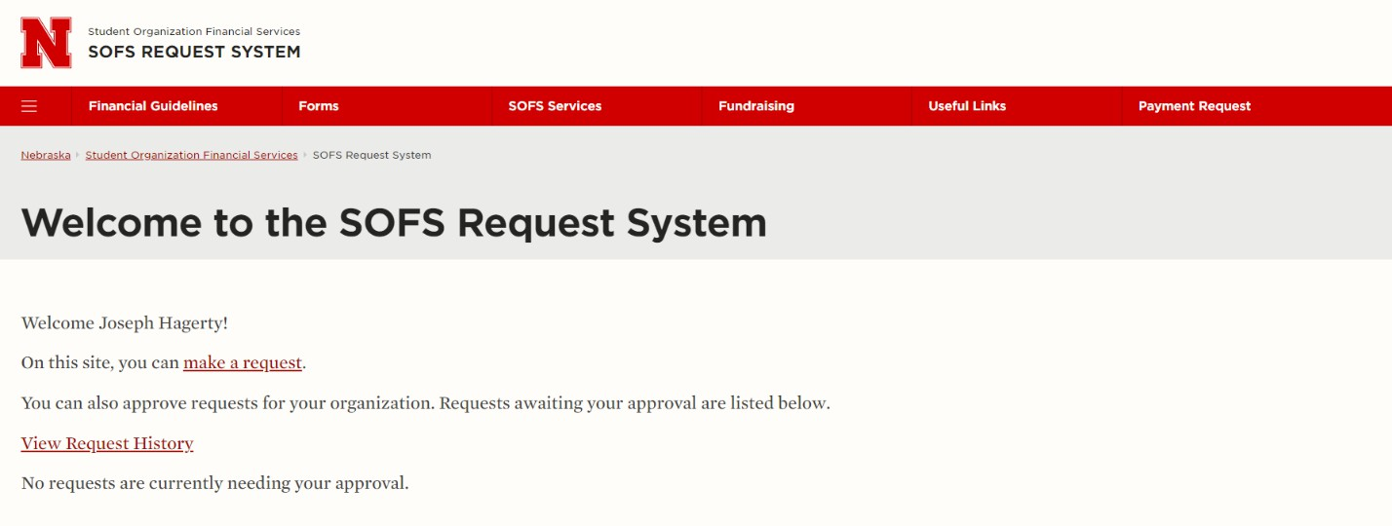
s.
the “View Request History” page unless you are an officer that is required to approve request

Request History & Status
- All requests that you have personally submitted or approved will show up on the request history page. Once all approvers have approved the request, it will appear as “Complete” under the status column.
- To view details of the request such as who has approved the request, click the “Details” hyperlink.
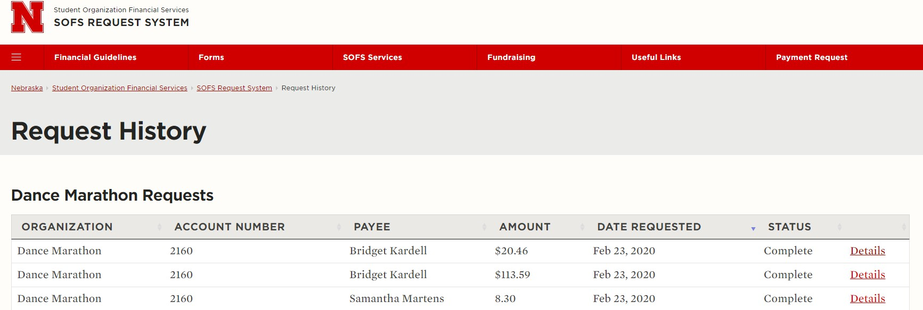
John Doe
John Doe
John Doe

Request Details
- Below is an example of the details page that can be viewed for each request.
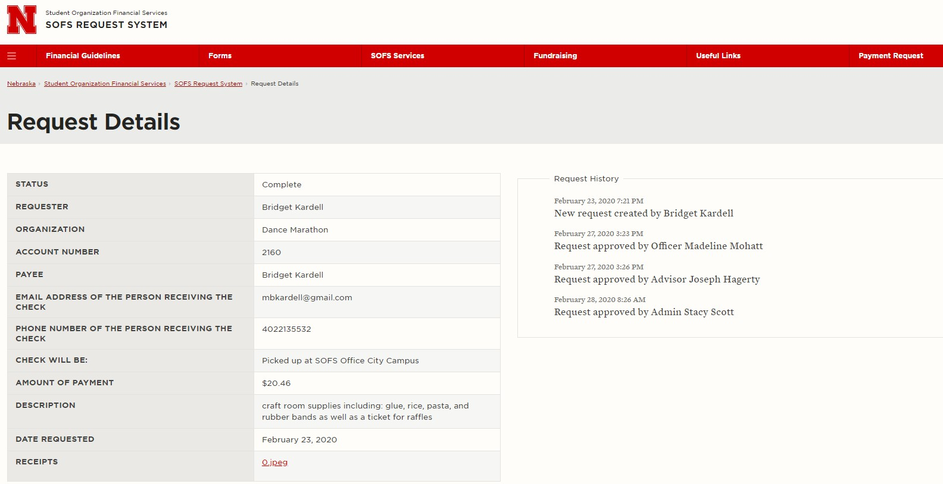
John Doe
John Doe
John Doe
9999
Jim Buck
John Doe
Johndoe2@unl.ed

402-472-9999

Final Thought for RSO Treasurers
- Please have all purchasers submit their own reimbursements using the SOF’s request system. This simplifies the process and prevents system errors such as officers/advisors signing for their own reimbursement.

- Because advisors must approve all requests, advisors should abstain from purchasing items for RSOs. If advisors submit a reimbursement using the SOFS Request System, it will lead to a system error. If a sizeable purchase needs to be made and is to expensive for a student to purchase, SOFS for further assistance.

- If you have any questions related to the use of the SOFS request system, please contact SOFS at (402-472-5667| sofs@unl.edu)

